Midtown Sculpture Walk
Grades 6-8 Teaching Guide
Boundless Voyage by Clifton Cox
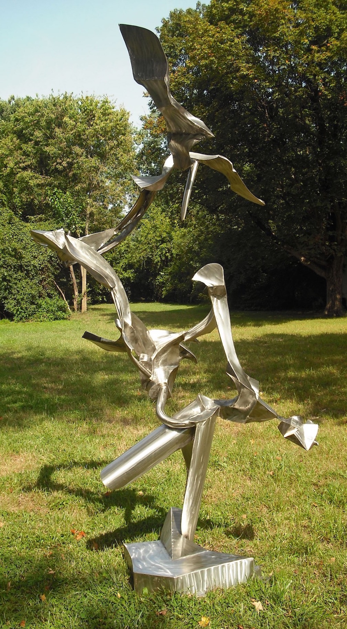

Created by Tyler Andrews for EDUC-3240: Teaching Toward Equity in ELA
Taught by Dr. Julie Rust
Millsaps College Spring 2020

6-8
Introduction
You are looking at a sculpture of art called the Boundless Voyage. This piece of art represents the important role of music and dance in the life of Native American’s ceremonial purposes of expression, healing, and vision quests. The way the sculpture is built is to demonstrate the energy and dance expression honoring the endless journey of the spirits.
Before going through the art walk, please click on the following link to understand who Clifton Cox is and what inspires him to create these sculptures.
https://www.coxsculpture.com/about-1
Questions/Prompts to Guide Sensemaking
- How do artists work?
- How do artists and designers determine whether a direction in their work is effective?
- How do artists and designers learn from trial and error?
Clifton Cox spent over 600 hours working on one of his large-scale sculptures. An artist takes a lot of time contemplating how they want to move forward with their projects. It is never simple and easy to produce a massive project like this one without dedication. What is a piece of work you’ve done that has taken several hours or days for you to complete? For example, have you had school projects, house projects, or even spent numerous hours preparing for a big game or tournament? How did you feel after finishing that project, event, or activity?
During your visit to the park, take a few minutes to examine the sculpture. Think about how it was created, why it might have taken so long to make, and what purpose the sculpture has. Using what mother nature has provided (sticks, leaves, rocks, etc.), see what type of sculpture you can build. Gather your materials, spread out, and be creative. We will spend 15-30 minutes on this activity. Once you are finished, take a photo of your work and tag #MidtownSculptureWalk and #MidSouthSculptureAlliance.
Once we return from our visit to the Midtown Sculpture Walk, you will work with a partner to create a sculpture using recyclable material that we have in the classroom. You will spend approximately 20-30 minutes creating your “Voyage” and then you will share with the class.

