Midtown Sculpture Walk
K-12 Teaching Guide
Overview: How Public Art Connects to the Community
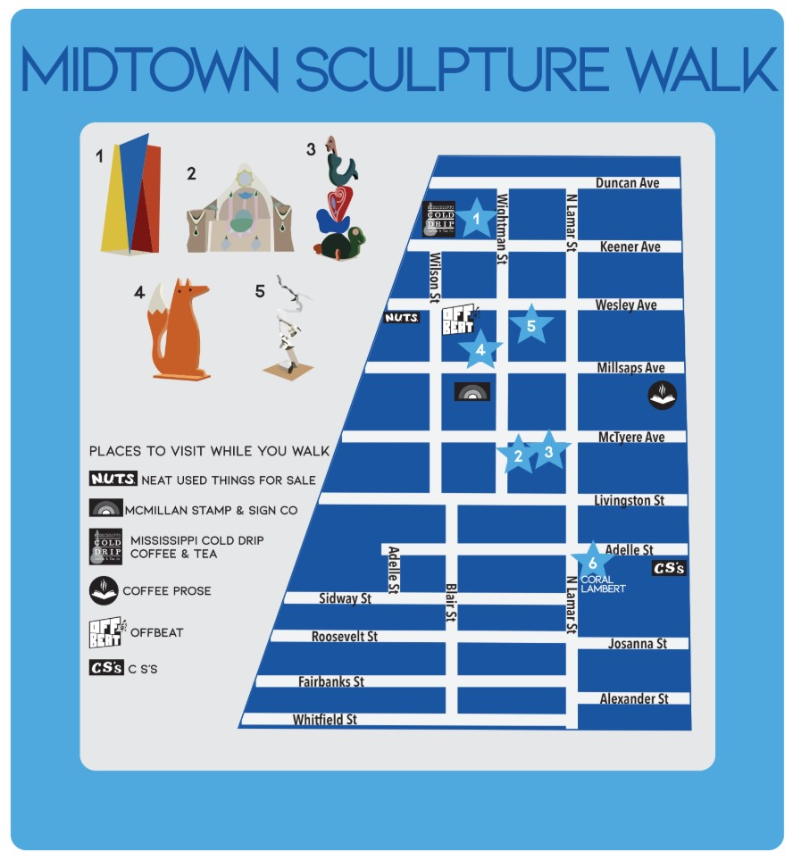
Created by Shelby Conerly for EDUC-3240: Teaching Toward Equity in ELA
Taught by Dr. Julie Rust
Millsaps College Spring 2020

K-5

Hello! Today you will be touring the Midtown Sculpture Walk! These sculptures were made by people all around the country and have influences from all over the place! Have you seen art in your community before and wondered how and why it was there? Well get ready to see even more! Here, you will have viewed local art in your community and also be creating your own! Through these activities, you will learn about how art can connect and impact the community it is in, and how to relate those meanings into your own art!
During:
What do you think these sculptures have to do with the community they are placed in? Do you think any of them connect to Jackson specifically? Which ones and how?

After:
Google Eudora Welty. Who was she, and where was she from?

Here you see the beautiful “Eudora Welty Wreath” by Professor Tordella-Williams. While it is not a sculpture you viewed on the Midtown Sculpture Walk, it ties in well. This is currently located in Hattiesburg, Mississippi at the University of Southern Mississippi. What do you notice is on the wreath and why do you think Professor Tordella-Williams chose to put that on it? What does Eudora Welty have to do with the “Eudora Welty Wreath”? How do you think this wreath connects with Jackson?

Eudora Welty Wreath by Kristen Tordella-Williams
Cast iron, 5.5’ x 5.5’ x 1.5’, 2016
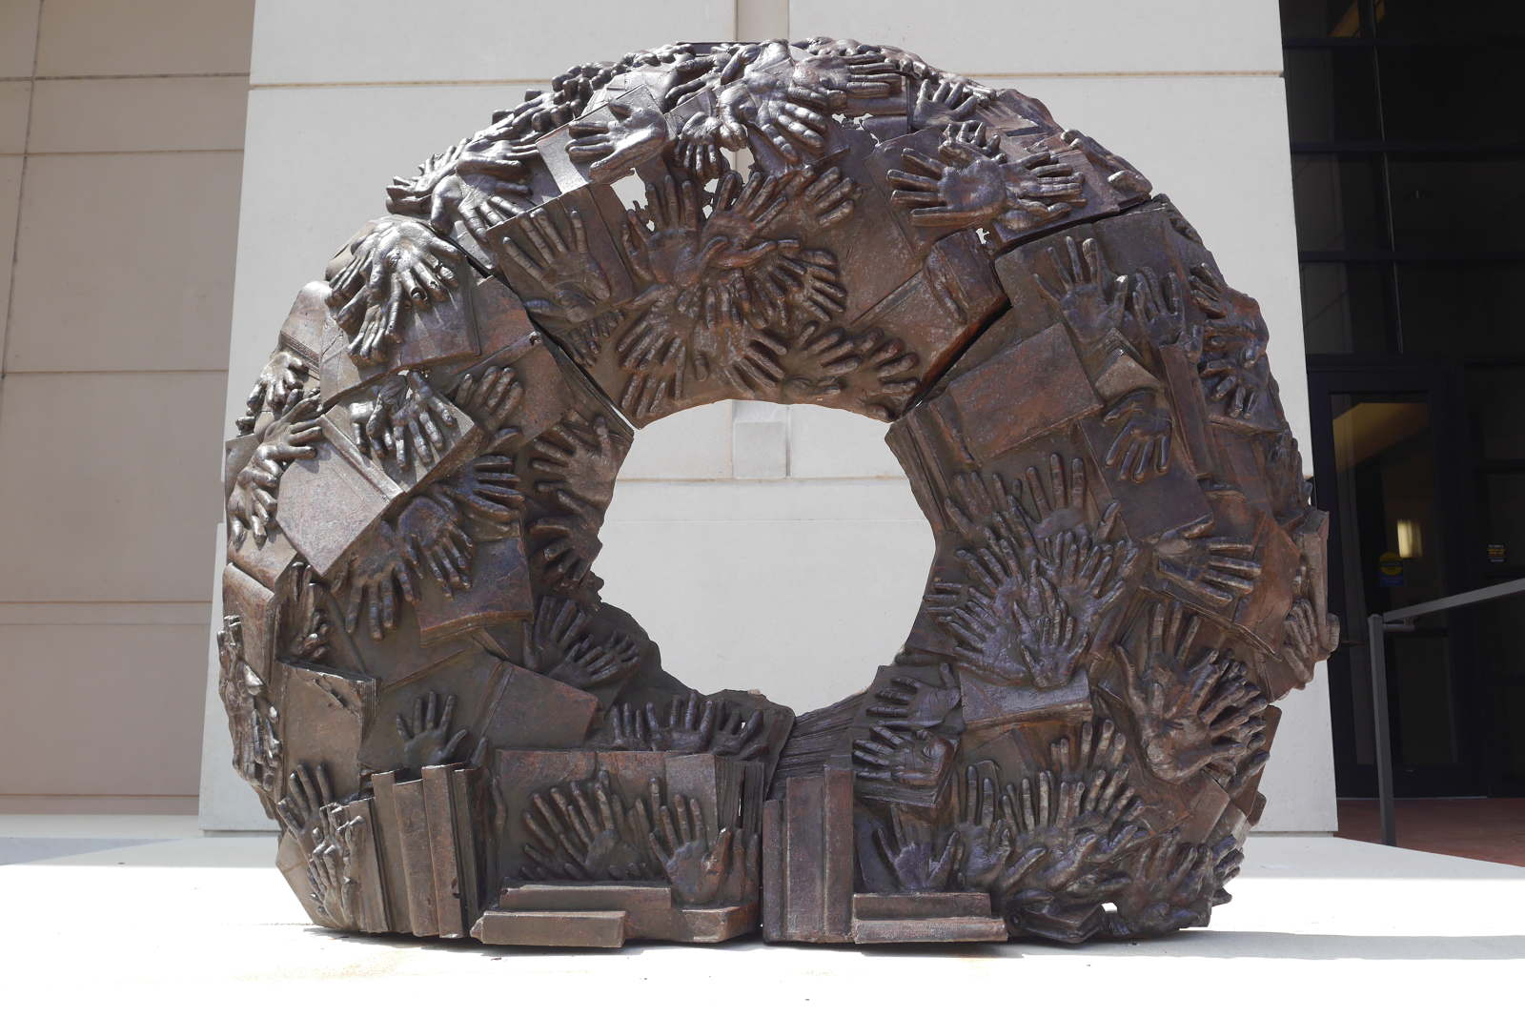

If you were to make a sculpture about yourself and where you’re from, what would it look like? What parts of you would be included on it? How do these symbols stand for you and where you are from? Is it big and round like the Eudora Welty Wreath? Or is it small and compact? Can people come by and feel your art?

- First, brainstorm some words or pictures that come to mind when you think of yourself and where you are from. Try to think of at least FIVE things.
- Next, when you think of your art, what is it made of? Paper and glue? Rubber bands? Clay? The possibilities are endless!
- Finally, draw what you imagine represents YOU the best. Be sure to include part of where you are from in it too! How do you connect to your community? What do the people in your community enjoy doing? Reading? Exercising? Socializing?

6-12

Hello! Here you will be going through an online sculpture walk today! These sculptures were made by people all over the country and have been all over the place. As you look through these pieces, keep in mind the theme of community. What do these sculptures have to do with the community they are in, and how do they affect the people in this community? Here, you will not only see lots of art, but also create your own! You will be learning about how art ties to its community and how it impacts the community it is in.

Can you guess where each piece of art is located in our nation? (Answer Key at End)
Choices: Miami, Fl Manhattan, NY St. Louis, MO Los Angeles, CA

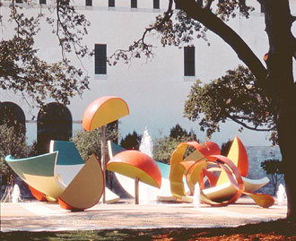
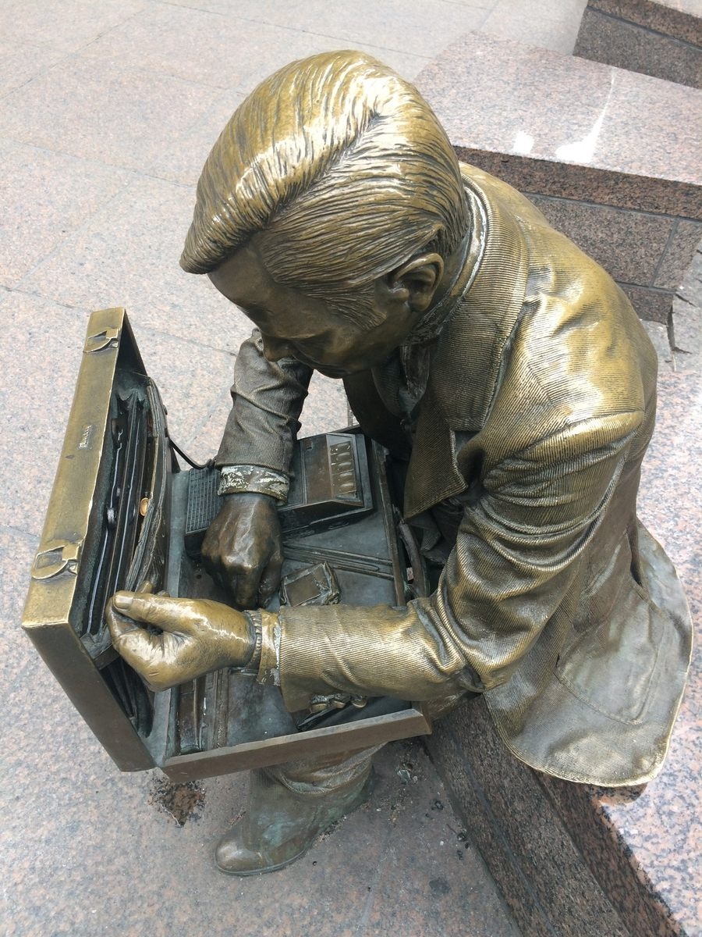

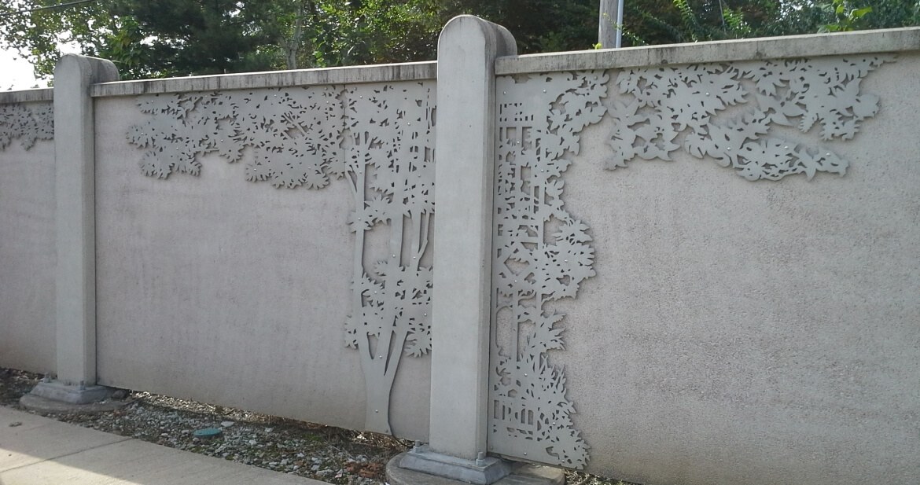

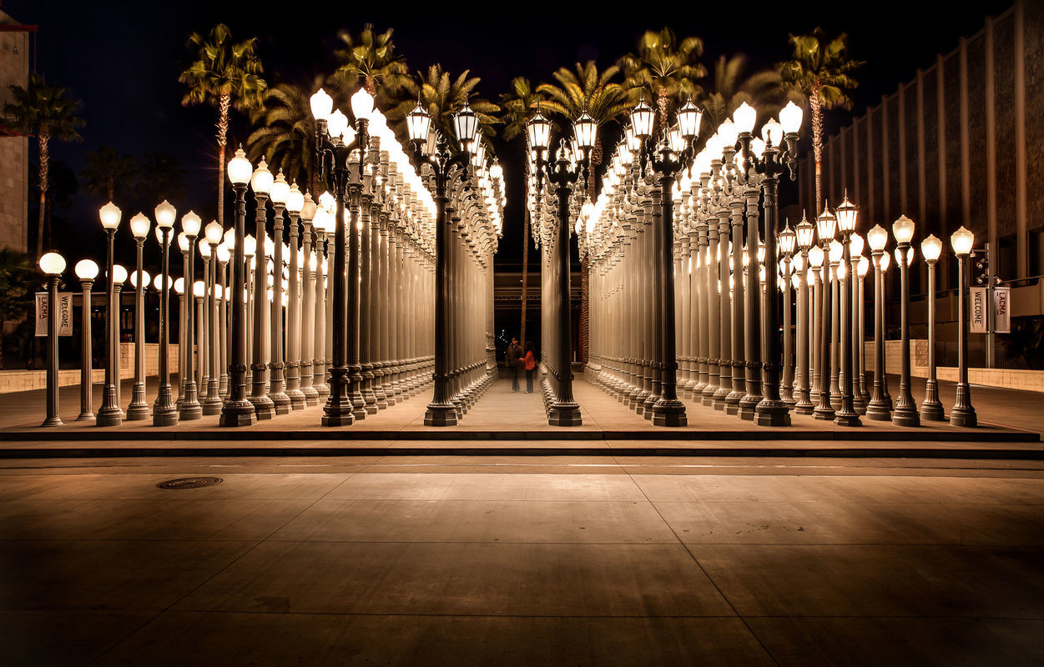

While looking at these pieces:
What do these sculptures have to do with the community they’re in? Do any of them stick out to you as being more connected to the community than others? Which ones? Why?

After going through the sculpture walk:
- After your tour, pick one famous person from your community or home state and make a sculpture about them and their lifestyle. You can make one physically, make a drawing, make something of paper mache, or whatever you would like! However, you must be able to explain your reasoning.
- Write a brief report (three paragraphs) about the person you picked, and how they are portrayed through your art. This should include:
  - Who your art is about
  - A brief description about them and their life and the community they came from
  - How you connected them to the art you made
  - How your art connects with the community chosen

A couple examples of similar art for inspiration:

The Eudora Welty Wreath by Kristen Tordella-Williams
Cast iron, 5.5’ x 5.5’ x 1.5’, 2016
Photo courtesy of artist

Northwest Atlanta Globe by Allen Peterson
Cast aluminum, steel bolts, stainless, stained concrete,
8 foot diameter cast aluminum spheroid, roughly 30 x 35 ft plaza, 2016
Photo by Bryan Peterson

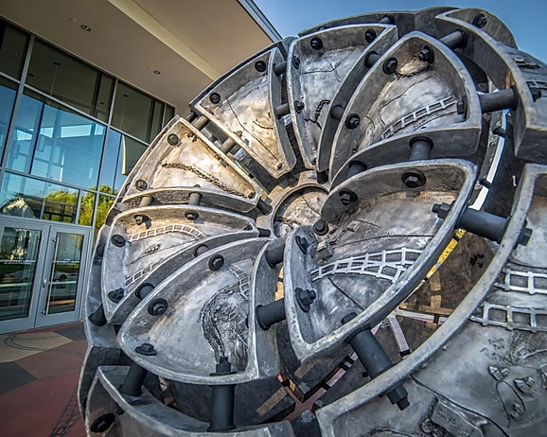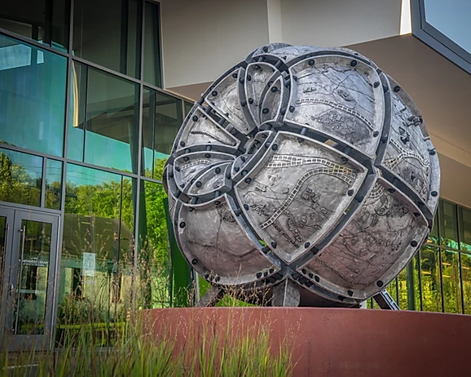

Answer Key to Matching Activity:

“A Walk in the Park” by Andy Cross, Caitlin Harris, and Tai Tessmer
St. Louis, Missouri
- 6’4” x 10’6”, 2006, Water jet cut aluminum panels mounted on cement wall
- Photo by Metro Arts in Transit
- “An overlay of lacy aluminum silhouettes titled A Walk in the Park embellishes the distinctive cement privacy fence called the Catlin Wall that runs east from the intersection of Skinker Boulevard and Forest Park Parkway along the south side of the road parallel to the MetroLink tracks. Pedestrians, car passengers and MetroLink riders enjoy this visual enhancement whenever they pass by.” (Metroarts in Transit, n.d.)

“Double Check” by John Seward Johnson II
Manhattan, New York
- 1982, bronze
- Photo by Luke J Spencer
- “Double Check” was sculpted by John Seward Johnson II in 1982, and placed in the park. The only concession to his being from the early 1980s is the oversized calculator and portable tape recorder lying in his open briefcase, items he was double checking before heading into one of the towering office buildings surrounding the park. After 9/11, first responders mistook him for a survivor, only to find bronze beneath the dust. Soon after, a plaque was put in front of him stating, “the ‘everyman’ businessman presence in Liberty Park who before, had faded into the background amongst his human brethren, has been called ‘the survivor’....this bronze man sits again in his original site bearing scratches and bruises he sustained that day as a poignant reminder of hope and endurance for us all.” (Spencer, 2017)

“Urban Light” by Chris Burden
Los Angeles, California
- 200 20-30 ft Street lamps, painted gray, 2008
- Photo by Chris Burden Estate
- Starting in the 1980s, Burden began collecting antique street lamps, creating a smaller version of Urban Light at his Topanga Canyon home. It caught the attention of museum director Michael Govan, and the entire piece, plus another four dozen or so additional lamps, was moved over to LACMA in 2008. With a conversion to solar power, the lamps have shined ever since, as both a throwback to the early days of L.A.’s city life, and a look to its future as a mecca for art and green technology. (Atlas Obscura, 2017)

“Dropped Bowl with Scattered Slices and Peels” by Claes Oldenberg
Miami, Florida
- 17 pieces, steel, reinforced concrete, fiber-reinforced plastic, stainless steel, 1984
- Photo courtesy of artists
- This monumental outdoor sculpture represents an imaginary moment in time when a huge bowl of orange slices and peels drops to the ground and shatters. The artwork includes eight bowl fragments in cast concrete with an overall weight of 124,000 lbs., four peels in steel plate with painted surfaces, and five orange sections executed in reinforced cast resin. (Culture NOW, n.d.)

References
A Walk in the Park. (n.d.). Retrieved from https://racstl.org/public-art/a-walk-in-the-park/.

Dropped Bowl with Scattered Slices and Peels: Claes Oldenburg, Coosje Van Bruggen and Miami-Dade County Art in Public Places. (n.d.). Retrieved from https://culturenow.org/entry&permalink=09314&seo=Dropped-Bowl-with-Scattered-Slices-and-Peels_Claes-Oldenburg-Coosje-Van-Bruggen-and-MiamiDade-County-Art-in-Public-Places.

Gorgeous Rows of Vintage Street Lamps Shine on L.A.'s Miracle Mile. (2017, June 2). Retrieved from https://www.atlasobscura.com/places/urban-light.
Spencer, L. (2017, April 14). The Double Check Businessman. Retrieved from https://www.atlasobscura.com/places/double-check-businessman-sculpture.

