Midtown Sculpture Walk
K-12 Teaching Guide
Double Wedge by Carl Billingsley

Created by Daniela Sandoval for EDUC-3240: Teaching Toward Equity in ELA
Taught by Dr. Julie Rust
Millsaps College Spring 2020

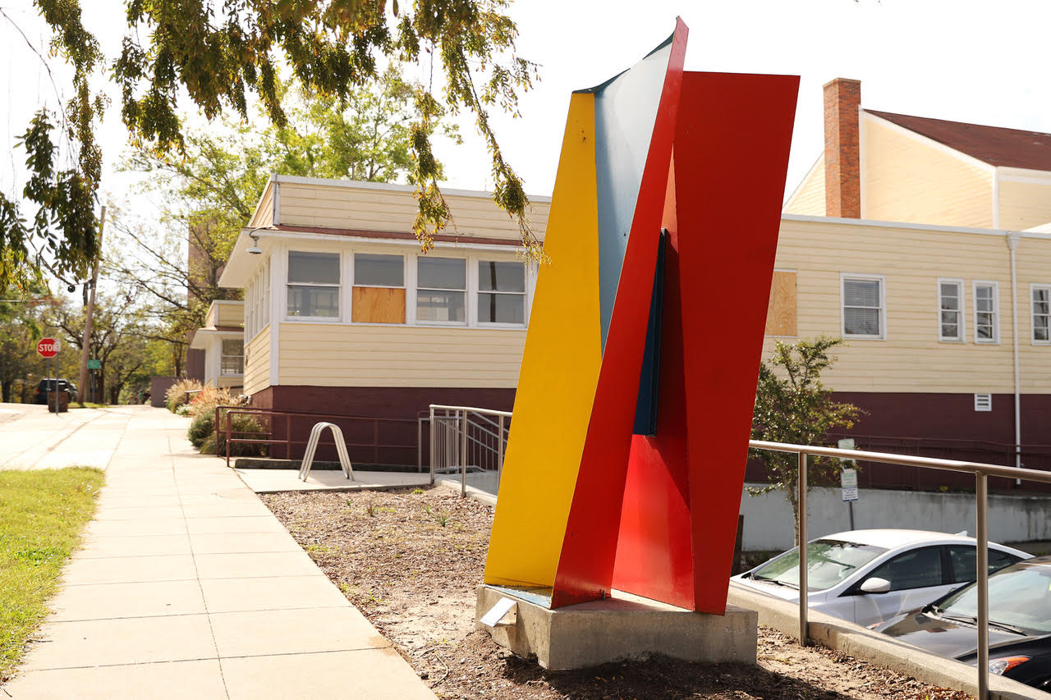

Intro
K-5
Double Wedge is a fabricated steel piece created by Bill Billingsley. This sculpture has primary colors that, when combined, make more colors known as secondary colors. It has the shapes of triangles and squares depending on how you look at it. It can also look like two sculptures from some angles, and one sculpture from others. It is a sculpture with many meanings and was inspired by Carl's childhood experiences. It has now been selected to be exhibited in Midtown Jackson and is on sale.

6-8
Double Wedge is a fabricated steel piece created by Bill Billingsley. This piece has primary colors (red, yellow, blue) that reflect light off its surfaces to create secondary colors. It also gives the illusion of looking like one sculpture from some angles and two sculptures from others. It is a very captivating piece and was inspired by Carl's work by helping his grandfather who was a carpenter, his love for reading, and other childhood experiences. This piece was selected in a competition to be exhibited in Midtown Jackson and is also for sale.

9-12
Double Wedge is a fabricated steel piece created by Bill Billingsley. This is an illusionistic piece with primary colors (red, yellow, blue). It is shaped to look like a single standing piece from one point of view and two standing pieces from others. It is also shaped to reflect light off its surfaces to create more colors through the reflection of the secondary colors. It is a very captivating piece and was selected in a competition to be exhibited in Midtown Jackson and is also for sale.

K-5 Activities

Before going to Midtown Sculpture Walk

- Sketch Artist: Before knowing what the sculpture looks like, the children can play a game. One person (Child 1), with access to the image of the sculpture, will try to explain the image using words to their partner (Child 2). As Child 2 listens, they will attempt to draw the sculpture using only what Child 1 describes. After the drawing is completed, both children examine the actual image of the sculpture and compare/contrast the drawing with the piece of art and write a story with their partners about what they observed.

- Food for Thought: This work is made out of steel. Why do you think Carl decided to make this piece out of steel as opposed to other material? What could it represent and why was it chosen to be here in Midtown?

While at the Midtown Sculpture Walk

- Musical Sculptures: To help children understand the point of this activity, read this quote to them: “First impressions are not what they seem, things are not simple, and how can that look like that from here but be so different from another viewpoint.” -Carl Billingsley. You can play musical chairs, but without chairs, and the children walk in a circle around the sculpture. When the music stops. the children can examine the statue from where they're standing. This process can be done a few times to give the children the opportunity to see the piece from multiple views.

- Philosophy Walk: As children walk around the sculpture, they can answer the following questions:
  - What do you think the different point of views mean?
  - Why do they look like the same piece on one side, but different ones from another?
  - Do different angles mean different things?
  - What is your favorite angle and why?
  - What is your opinion about this piece?

After returning from the Sculpture Walk

- What do the colors symbolize?
  - When asked why he chose the colors he did for this sculpture, Carl Billingsley said, “I use primary colors for my sculptures because the geometry and shape of my works often allow for the reflection of light from one surface of the sculpture onto another, which can sometimes create the effect of a secondary color.”
Choose four different colors and come up with different meanings for each of them. Then, try to make a similar model. The model can be made out of paper, clay, foam, or anything that is available . Write about why it is shaped the way it is and the meaning behind the different angles and why you chose those colors as well as what the colors mean to you.

  - Word Story: When you go look at the sculpture, jot down 5-10 words that come to mind when seeing this piece. Later, try writing a story using the words they have written down from the sculpture.

Standards
- VA: Re7.2.PK Perceive and analyze artistic work
  - “Visual imagery influences understanding of and responses to the world.”
- CCSS.ELA-LITERACY.W.3.1.A
    - K-5: they can state an opinion about what the think the different POVs mean, and create an organizational structure that lists reasons
- Va:Pr6.1.5 Convey meaning through the presentation of artistic artwork
  - “Cite evidence about how an exhibition in a museum or other venue presents ideas and provides information about a specific concept or topic.”
- Va:Cn10.1.4 Synthesize and relate knowledge and personal experiences to make art
- “Create works of art that reflect community cultural traditions.”
- K-5: use simple words or new vocab they are learning
- CCSS.ELA-LITERACY.W.3.2
  - “Write informative/explanatory texts to examine a topic and convey ideas and information clearly”

6-8 Activities

Before going to the Midtown Sculpture Walk

- Sketch Artist: Before knowing what the sculpture looks like, the children can play a game. One person (1), with access to the image of the sculpture, will try to explain the image using words to their partner (2). As person 2 listens, they will attempt to draw the sculpture using only what person 1 describes. After the drawing is completed, both children examine the actual image of the sculpture and compare/contrast the drawing with the piece of art by writing a short story.

- Food for Thought: This work is made out of steel, why do you think Carl decided to make this piece out of steel as opposed to other material. What could it represent and why was it chosen to be here in Midtown.
  - Before going to look at the sculpture in person, the students can do some research on Midtown Jackson to get some insight about the geographical area. Once they are looking at it, they can write about why they think this piece is a good fit for Midtown Jackson and how it reflects on community values.

While Enjoying the Midtown Sculpture Walk

- Angles of Angels: According to Carl Billingsley, confusion or visual instability leads to a deeper exploration of the sculpture. By looking at the sculpture from the different POVs, write about how you, or others can appreciate the complexity of the sculpture.
Use different stickers on the ground, or temporary spray paint, to show the children where to stand to see the different illusions.

- Philosophy Walk: While observing different points of view, you can answer the following questions:
  - What do you think the different points of view’s mean?
  - Why do they look like the same piece on one side, but different ones from another?
  - How do the different views differ?
  - Are there more complex angles than others?
  - Do the more complex angles bring out different moods compared to the less complex ones?
  - What color variations do you see in the different angles?

After Returning from the Midtown Sculpture Walk

- What do the colors symbolize?
  - When asked why he chose the colors he did for this sculpture, Carl Billingsley said, “I use primary colors for my sculptures because the geometry and shape of my works often allow for the reflection of light from one surface of the sculpture onto another, which can sometimes create the effect of a secondary color.” Choose 4 different colors with different meanings and try to make a similar model out of foam, clay, paper, or whatever is available. Write a poem of your choice demonstrating the beauty of the different shapes of your sculpture as well as the meaning of the different colors. Create a color wheel and/or chart of primary and secondary colors to help you choose which ones to use.

- Word Story: When you go look at the sculpture, jot down 5-10 words that come to mind when seeing this piece. Later, try writing a story using the words they have written down from the sculpture.

Standards

- VA:Re7.1.PK Recognize art in one's environment
    - “Individual aesthetic and empathetic awareness developed through engagement with art can lead to understanding and appreciation of self, others, the natural world, and constructed environments.”
- CCSS.ELA-LITERACY.W.7.1.A
  - 6-8: They can state a claim about the different POVs, acknowledge their differences and organize the reasons and evidence logically.
- Va:Pr6.1.6 Convey meaning through the presentation of artistic artwork
  - “Assess, explain, and provide evidence of how museums or other venues reflect history and values of a community”
- Va:Cn10.1.8 Synthesize and relate knowledge and personal experiences to make art
  - “Make art collaboratively to reflect on and reinforce positive aspects of group identity.”
- CCSS.ELA-LITERACY.W.7.3
  - “Write narratives to develop real or imagined experiences or events using effective technique, relevant descriptive details, and well-structured event sequences.”

9-12 Activities

Before going to the Midtown Sculpture Walk

- Sketch Artist: Before knowing what the sculpture looks like, the children can play a game. One person (1), with access to the image of the sculpture, will try to explain the image using words to their partner (2). As person 2 listens, they will attempt to draw the sculpture using only what person 1 describes. After the drawing is completed, both children examine the actual image of the sculpture and compare/contrast the drawing with the piece of art by writing a comparative essay.

- Food For Thought: This work is made out of steel, why do you think Carl decided to make this piece out of steel as opposed to another material. What could it represent and why was it chosen to be here in Midtown?
  - Before going to look at this piece, you can do some research on a current event going on around the world. Once going to look at the sculpture, you can use the shapes, color, angles, or general beauty of the sculpture to try to connect it with the event they have picked out.

While Enjoying the Midtown Sculpture Walk

- Angles of Angels: In regards to the illusion, Carl Billingsley said, “I want to create a certain level of confusion or visual instability in the perception of the viewer. This leads to a deeper exploration of the sculpture. First impressions are not what they seem, things are not so simple, and how can that look like that from here but be so different from another viewpoint?” Take your phones out and take pictures of the sculpture from different views. Using these pictures, pick their favorite angles and write about the different feelings of each angle, why some are more complex than others, what different shapes in the different angles can mean, or anything that “contributes to understanding messages or ideas conveyed” in Double Wedge.

- Philosophy Walk: While observing different points of views of the sculpture, the children can answer the following questions:
  - What do you think the different points of view mean and what makes them unique?
  - Why do they look like the same piece on one side, but different ones from another?
  - What makes one perspective more complex than another?
  - Are there any more angles you’d like to explore? Why?

After Returning from the Midtown Sculpture Walk

- What do the colors symbolize?
  - When asked why he chose the colors he did for this sculpture, Carl Billingsley said, “I use primary colors for my sculptures because the geometry and shape of my works often allow for the reflection of light from one surface of the sculpture onto another, which can sometimes create the effect of a secondary color.” Choose 4 different colors with different meanings and try to make a similar model. Write about why it is shaped the way it is and why you chose those colors. You can do this by investigating and developing awareness of perception, knowledge, and experiences. Create a color wheel and/or chart of primary and secondary colors to help you choose which ones to use.

- Word Story: When you go look at the sculpture, jot down 5-10 words that come to mind when seeing this piece. Later, try writing a story using the words they have written down from the sculpture or even try making a painting or sculpture

Standards
- VA:Re8.1.8 Interpret intent and meaning in artistic work
  - “Interpret art by analyzing how the interaction of subject matter, characteristics of form and structure, use of media, art-making approaches, and relevant contextual information contributes to understanding messages or ideas and mood conveyed.”
- CCSS.ELA-LITERACY.W.11-12.1.A
  - 9-12: By doing some research before going to look at the peace and from the evidence they gather there, the students can write about the different claims from the different POVs, establish the significance of the claims, distinguish the claims from alternate or opposing claims, and create an organization that logically sequences claim, counterclaims, reasons, and evidence.
- Va:Pr6.1.HS.l Convey meaning through the presentation of artistic artwork
  - “Analyze and describe the impact that an exhibition or collection has on personal awareness of social, cultural, or political beliefs and understandings.”
- VA:Cn10.1.l Synthesize and relate knowledge and personal experiences to make art.
  - “Through art-making, people make meaning by investigating and developing awareness of perceptions, knowledge, and experiences.”
- CCSS.ELA-LITERACY.W.9-10.3
  - “Write narratives to develop real or imagined experiences or events using effective technique, well-chosen details, and well-structured event sequences.”

References

- http://billingsleyatelier.com/?page_id=448
- http://www.corestandards.org/ELA-Literacy/W/introduction/
- http://www.corestandards.org/ELA-Literacy/W/7/
- https://www.mdek12.org/sites/default/files/MS%20CCR%20Arts%20Learning%20Standards%20for%20Visual%20Arts%202017%20FINAL.pdf
- http://artscouncilofwilmington.org/wp-content/uploads/2018/11/Billingsley-Double-Wedge-in-Place.jpg

