Midtown Sculpture Walk
K-12 Teaching Guide
Turtle Down Totem by Gwendolyn Kerney

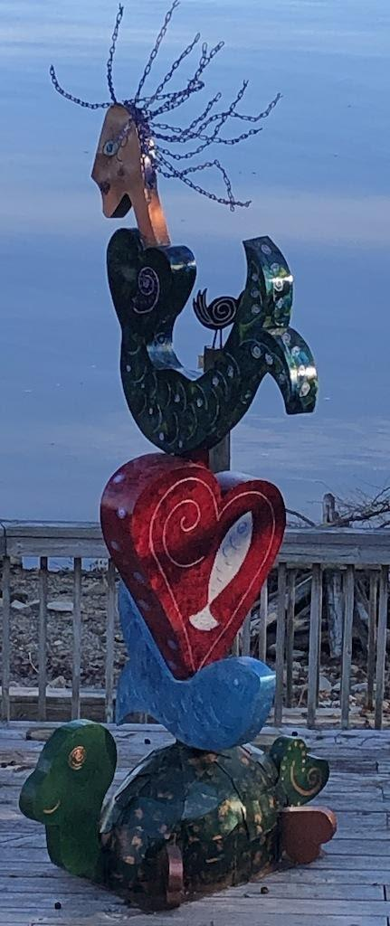

Created by Camille Landry for EDUC-3240: Teaching Toward Equity in ELA
Taught by Dr. Julie Rust
Millsaps College Spring 2020

Overview
Looking at Turtle Down Totem, I just knew I had to contact the artist to find out what this sculpture represents. After talking to the artist, I found out so many adventures into what led up into making this piece. The love for mermaids started when Gwendolyn was at an early age. She loves swimming, boating, blue skies, sunshine and the sea; particularly in the Greek Islands where she travels every year. The artist travels to the Greek Islands every year for her birthday, which inspired her because of her love of swimming, boating, blue skies, the sunshine, and of course, the sea.
Travel is a passion of hers, as is color and whimsy, which helps inspire her art. Once on vacation, she went swimming with an enormous Hawaiian Green Sea Turtle known as "Honu," which symbolizes good luck. Sea turtles have flippers instead of legs and cannot retract their heads, which is true of her sculptured turtle," Its turtles all the way down." This saying is a mythological expression of the idea that the world rests on the back of stacked turtles. A heart ultimately symbolizes emotion, affection, and love. The artist likes to include hearts in her sculptures to show how hearts generate a magnetic field that connects us; and it is her way of connecting through the joy and art of her sculpture.
All of the sculptures created by Gwendolyn Kerney are completed by drawing her designs directly onto sheet metal plasma cut by hand; they are then fabricated by her partner, Jim Parris. He designs and makes metal furniture, not just for her, but for other artists. Once assembled, the pieces are primed, painted, and sealed by her. In addition to acrylic paint, the artist utilized some metal stain to help create a shimmering sea effect. Her work is created in her garage at home by the Tennessee River in Lenoir City, TN.

K-5
Intro: Gwendolyn Kerney is an artist who loves to discover the world about the life of mermaids and sea turtles. She loves to travel so much that she travels all across the world to find a mermaid. The reason for the heart is because her heart is so big, she wanted to show it for everyone to see. The creation of her piece is showing love for her mermaids and turtles. This story is about a mermaid and her loving friend, a turtle. Do you know the story about the little Mermaid? I would say this is just like Arial hanging out with the friends in the ocean. Except this Mermaid can have her tail above the water with her crazy hair. How many of you all think she has crazy hair? I think she does too but maybe her hair has magical powers just like Arial. Maybe she uses her hair powers to let her turtle friend talk also, just like Sebastian in the Little Mermaid! Does anybody think that is what her ability is for? I believe the heart means that she loves all of her friends, and her heart is so big that it cannot fit in her chest!!

Activities
Before:
- Alphabet Art: Can you spell out the words Mermaid, Turtle, or Heart? Each letter can be decorated in any way, but it has to be one of these three words using different resources that we can find. Some ideas include:
  - Try cutting out letters from a magazine or newspaper.
  - Spray shaving cream on a table and write the words in shaving cream. Bonus: the table will smell extra yummy after!
During:
- Dress in costumes- When you return home or back to school, try creating an under-the-sea costume of your own!You can choose to create a costume to become a mermaid, heart, or turtle.
- Make a tableau: Divide into groups of three, and assign each person the role as mermaid, heart, or turtle. (If you made costumes as suggested above, make sure to get in character.) Then, work together to use your bodies to represent the sculpture by creating a freeze frame, or tableau, together. Have your teacher or parent take a picture! Cheese!
After:
- Another idea is that they create the sculpture at home, and the totem could be anything that they like to do or a hobby. That way, they can have their touch on the statue. Since the sculpture is being supported by a totem. All you would need to do is gather any from what looks like a skinny stick. Then either use markers, paints or anything that could color the stick with. After make up your home sculpture that represents three hobbies, likes, events, people and activities that are most important to you and put them on the stick. Finally, after completing, you will have made your own sculpture.

6-8
Intro: While searching the Greek island and swimming through the water, she was reminded of the love of mermaids. The turtle also comes from her love of the sea and the luck it brings to her. The heart represents emotion and love, and that is why she is trying to show in her piece. I want to tell you a little story. Once upon a time, there was a mermaid swimming throughout the seas of Greek island. She was wondering where her travels will lead her to next. Maybe a new friend or some new findings? As she is swimming along, she notices a sea turtle just gliding along the ocean. She notices something is different about the turtle; she sees that it is swimming more at the bottom. It was strange for her because where she is from, the turtles love to swim more at the top of the ocean. Instead of just swimming past the turtle, she swam down towards the bottom and befriended him. After the two got to talking, a great friendship started.Why is the Mermaid looking for a new adventure?
- Why do you think the turtle is swimming at the bottom? Is it because in the sculpture, the turtle is at the bottom?
- Why do you think the heart is in the middle of the sculpture?
- Why do you think the sculpture has many colors throughout the piece?

Activities
Before:
- Ocean drawing - Draw a picture of the ocean of what you think it looks like. Use your imagination with markers, paint, pictures, letters, or any objects that best seems fit
After:
- Make a sculpture inspired by Turtle Down Totem- Create a sculpture at home using the totem form celebrating hobbies, interests, people or animals that the student enjoys. That way, they can have their own expression inspired by the piece. Since the sculpture uses the totem form, all you would need to do is gather an available cylindrical object like a paper towel roll or another readily available item. Then, use markers, paints or anything colorful to decorate the central pole with images or shapes to represent three hobbies, likes, events, people or activities that are most important to you and put them on the central pole. After completing, you will have made your own sculpture.
9-12
Intro: Mermaids for the artist are like the symbols for her loving the sea as a child. Her inspiration for the mermaid came from a metal mermaid sculpture located at the harbor entrance of the Greek island Spetses. As for sea turtles, they are known as “Honu," which symbolize good luck and long life. As for the heart, it expresses emotion, affection, and love. A heart represents love, emotion and affection so it creates a magnetic field, and that is her connection through the joy of her work.

Before: Look at the image of Turtle Down Totem for three minutes quietly. Then, write down 4 questions that you have about the sculpture. Then, read the artist’s description of the piece below and see if it answers any of your questions:
“I love mermaids and, from an early age, have fantasized that I may be one given. I love swimming, boating, blue skies, sunshine, and the sea; particularly, in the Greek Islands, where I have traveled the last five years during my birthday in May.
Travel is a passion of mine, as is color and whimsy, which inspires my art. A metal mermaid sculpture which I admire sits at the harbor entrance to the Greek Island of Spetses made by a famous Athenian sculptor, Natalia Mela, who died last year at age 96.
I once enjoyed swimming beside an enormous Hawaiian Green Sea Turtle known as “Honu," which symbolizes good luck, endurance, and long life. Sea turtles have flippers instead of legs and cannot retract their heads, which is true of my sculptured turtle. “Its turtles down” is a mythological expression of unknown origin, reflective of the idea that the world rests on the back of stacked turtles. I remember being thrilled when I caught (beating out all the men) the biggest bonefish ever in the Florida Keys and sculpted my fish based on that happy, fun memory.
The heart universally symbolizes emotion, affection, and love. I like to include hearts in my sculptures because our hearts generate a magnetic field that connects us, and it's my way of connecting through the joy and art of sculpture.
I draw all my sculpture designs directly onto sheet metal plasma cut by hand and then fabricated by my domestic partner, Jim Parris, who designs and makes metal furniture. Once assembled, the pieces are primed, painted, and sealed by me. In addition to acrylic paint, I utilized some metal stain to help create a shimmering sea effect.”

Guided Questions:
- After looking at the work and listening to the description, do you feel a connection between your story and the artist?
- Do you think she created a mini-story like you to go along with the statue?
- What inspired you from the statue to help create your account?

Activities
Write a poem-The topic of the poem is sculpture, and you need to create a poem of what is a sculpture or why do people create sculptures. For inspiration go look at the local art in your town, online and use your imagination. For example, this the Gwendlyn Kerney website that has plenty of sculpture and cool paintings- girlBglad.com

Photography- The students will take up to four different pictures at the site of the sculpture. Then for homework the students can draw their own version of the sculpture they saw at the site or create their own version inspired by their interests.

Creating an Instagram post- While at the Sculpture Walk, take a picture of the sculpture to post on social media, captioning it in a way that summarizes your response to the piece. Feel free to use emojis too! Tag your posts with #midtownsculpturewalk and #midsouthsculpturealliance so the artists and sculpture community see your reactions to the show!

