Midtown Sculpture Walk
K-12 Teaching Guide
Zorro by Jeffie Brewer
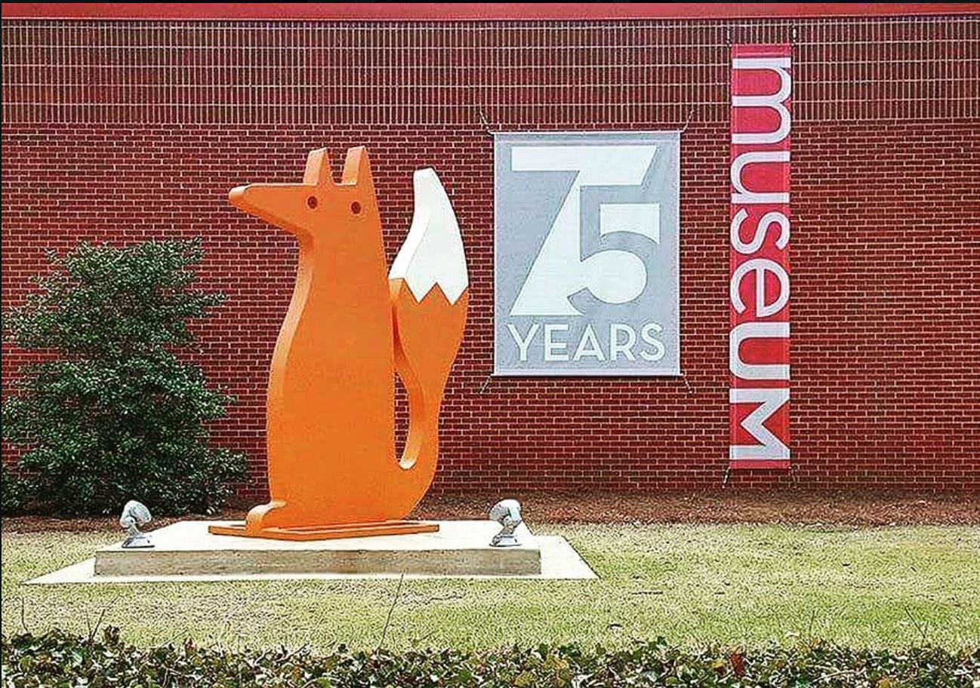
Created by Ashley Gremillion for EDUC-3240: Teaching Toward Equity in ELA
Taught by Dr. Julie Rust
Millsaps College Spring 2020

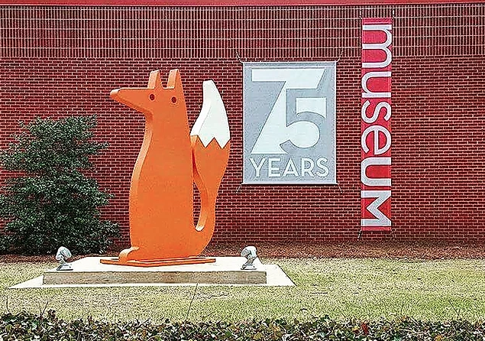
K-5
Brewer, Jeffie. Zorro. 2016. https://www.jeffiebrewer.com/3d?lightbox=image_l2y

Intro
You are looking at a sculpture of a fox, zorro in Spanish. Foxes have lots of meaning in the country of Mexico. Foxes can be sneaky and move reallllly slowly. They are very close watchers, so if they are trying to find something to eat they move quietly so no one hears them. Foxes are also sneaky, like somebody playing a trick on you. Foxes are very smart and energetic. How are you like a fox?

Questions
- What does the warm orange color of Zorro remind you of? A warm summer day? A tasty glass of orange juice? A burning fire?
- If you had to use three words to describe a fox, which words would you use?
- What emotion do you think the fox is experiencing? Happiness? Fear? Sneakiness? Excitement?
- If Zorro had to go on an adventure, where would it go and what would it do?

Activity
- Do you see a picture of the fox right now? If you do, walk as slowly as a fox would trying to catch its prey.
- Create a picture of a fox going to its super fun adventure that you talked about. Use lots of color and allow your drawing to illustrate the story. If you want to have your animal come to life, you can cut out your fox, or forest animal of choice, with an adult’s help. Fold down a flap at the bottom, and glue it to the paper for a fun pop-up edition!

6-8

Brewer, Jeffie. Zorro. 2016. https://www.jeffiebrewer.com/3d?lightbox=image_l2y

Intro
Zorro is the word for an animal in Spanish. Can you guess what it is? If you guessed fox, you are correct! Foxes are very smart and can seem tricky to us humans. However, they can guide us through certain situations when we think it is too hard. Foxes are great at adapting and coping with difficult things! Foxes are able to think quickly in new situations. Can you think of a time when something was going wrong and you saved the day? You are just like a fox! Be passionate and confident, as the red fox, Zorro, is and you will inspire others around to do just the same.

Questions
- Take a look at Zorro. How many elements of art can you see? (What type of material do you think is used? With what tools did the artist create Zorro? How long do you think it took?)
- Zorro, or fox in English, represents luck and magic. What kind of magic does the fox perform?
- How do you think this fox interacts with its environment? How does this fox match or go against its deep roots in Mexican folklore?
- If you were to become a fox, what would you do?

Activity
- If you are looking at Zorro, talk to someone around you about your favorite part of the sculpture.
- Create your own fox, or a forest animal friend in its favorite habit. Get creative and try to use as many materials as you have access to (crayons, markers, colored pencils, construction paper, googly eyes, and more!).
- Create a poem or short story about Zorro the fox. Where does it live? What does it do? How is this Zorro similar and different to its meaning in Mexican folklore?

9-12

Brewer, Jeffie. Zorro. 2016. https://www.jeffiebrewer.com/3d?lightbox=image_l2y

Intro
Foxes are incredibly adaptive creatures that especially work well in times of crisis. They are able to overcome fear of the unknown by observing their environment in the best way they can. If you are not able to see Zorro in person, you are viewing this sculpture walk virtually. The artist, Jeffie Brewer, said one of his greatest inspirations for Zorro was its roots in Mexican folklore, saying “the Zorro will reveal itself in times of great change.” Times are definitely changing. How can you be like Zorro and adapt to our new normal?

Questions
- What criteria would you create to properly and artistically evaluate Zorro as a sculpture? Possible categories include choice of shape and color, lack of facial features and detail, and types of materials used.
- How does the sculpture Zorro and its role in Mexican folklore help you to understand the animal and its significance? Was it what you always pictured a fox to be? How is it different?
- Think about other works of art that are similar to Zorro. Maybe they are other animal sculptures, have ties to Mexican folklore, or are from contemporary artists. How does Zorro compare?
- How do you feel the work is original, or not, to the artist and his message to Mexican folklore?

Activity
- Using artist critiquing methods, name two to three aspects of Zorro you enjoy and two to three aspects of Zorro you would change.
  - https://mdek12.org/sites/default/files/documents/Secondary%20Ed/MS%20CCR%20Arts%20Learning%20Standards%20for%20Visual%20Arts%202017%20FINAL.pdf
  - Use this document to help guide your critiquing.
- How has Zorro impacted your views of the importance of animals and symbolism of cultures? What is an animal that you find to be particularly inspiring, thought provoking, or interesting? How does this animal fit into your life and culture?
- Take a look at https://www.jeffiebrewer.com/. This is the artist that created the Zorro sculpture. Now, experiment with your own artist talent. Perhaps you work to imitate the bold yet simplistic style of Jeffie Brewer. Or, maybe you work to create your own, distinctive style. If so, what would a Zorro look like in your own artistic expression? Sketch it out and share it with a family member or friend.

